ENGINEERING
EXPLORATIONS

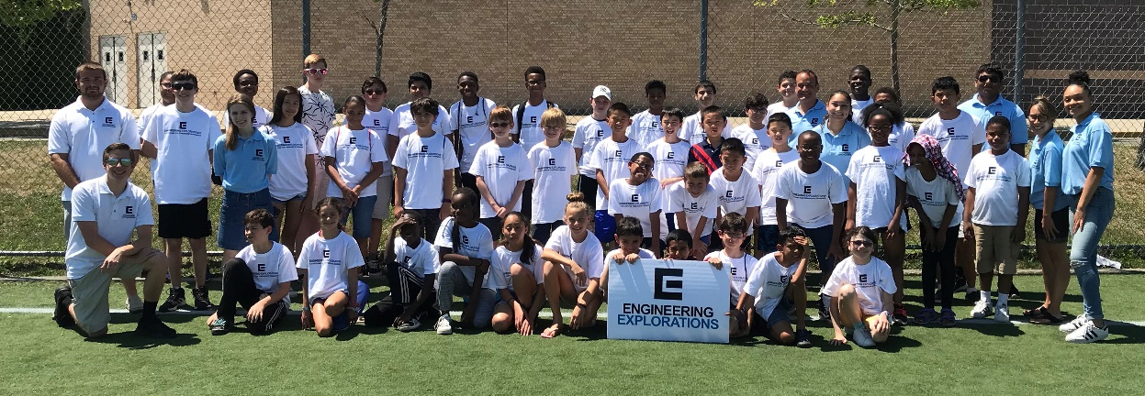
A STEM Camp for Tomorrow’s Engineers

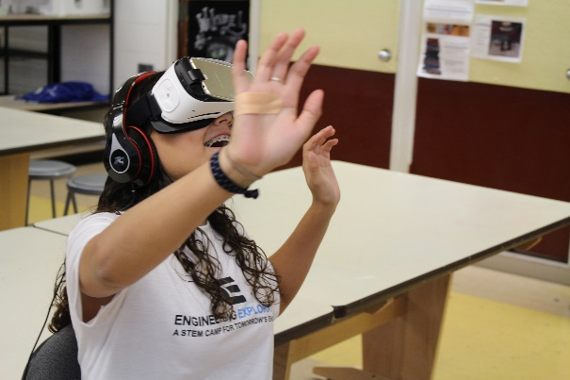
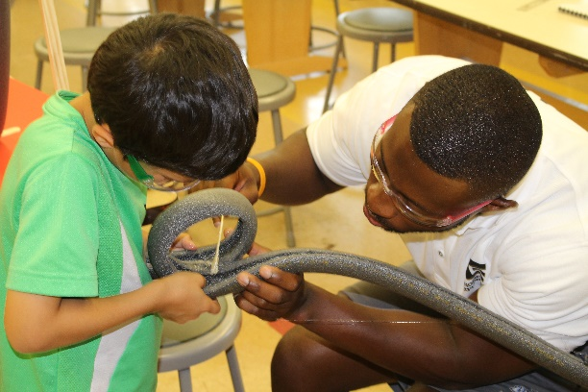

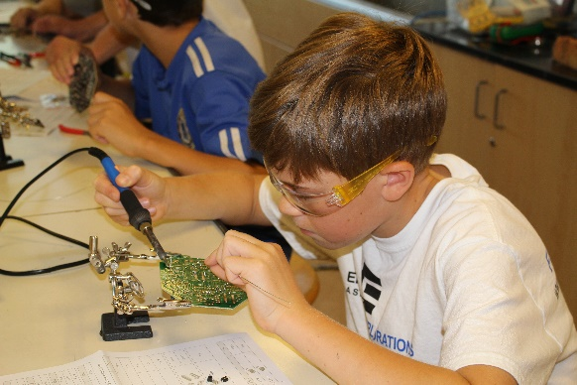
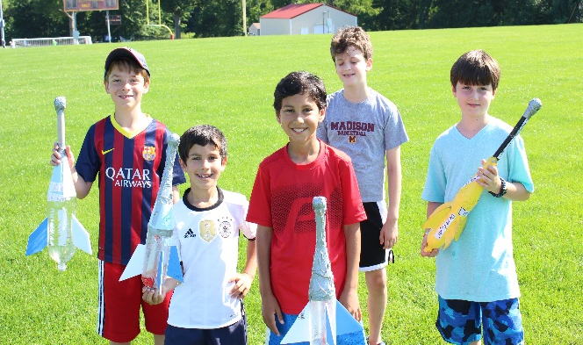

Robotics---3D Printing---Roller Coasters---Drones---Solar Cars--Water Powered Rockets--Circuitry--Programming--More

Engineering Explorations STEM Day 2020 Camp

July 6th - July 24th

9:00 am - 2:30 pm

Ages 8-15

Students participating in Engineering Explorations day camp will be exposed to various disciplines of engineering in a fun and exciting environment! They will be taught STEM principles within innovative hands-on projects. Students will document their learning in an "engineering portfolio" filled with activities and rigorous STEM content that they will complete throughout camp. They also keep ALL projects they fabricate! These include a marble run, water powered rockets, and solar powered fan in Foundations of STEM course. Solar powered cars, model skyscrapers, and roller coasters in the Engineering Design course. Students get to design their own T-shirt and sticker designs in the 3D Prototyping and Graphic Design course. In addition, they fabricate alarm circuits, robotic circuits, and learn Arduino programming in the Robotics: Fabrication and Programming course. Students will get to enjoy the summer weather each day during their “technology recess” where they will get to fly quad-copter drones, drive RC cars, play vintage video games, and examine the latest technologies such as virtual reality. We strive to build not only your child’s academic skills but their leadership skills as well through cooperative learning in a supportive environment.
Testimonials

"My son enjoyed the camp and always looked forward to the next day's activities. He was exposed to the basic principles of Physics and Engineering and loved building the roller coaster and rocket."

--Jon J.—

"My son loved going to camp every day and I loved that he was both having fun and learning about how things work."

--Kate R.—

"Engineering Explorations was a great camp because it is easy to make friends. Even if you know a lot about Engineering, you will still learn something new and have a great experience"

--Michael, camper—

"My daughter loved this camp - she was excited to go every day, she enjoyed the instructors (Mr. Del.) and she learned something - what more can you ask for from a camp"

--Madhavi S.--

Our Courses
Foundations of STEM
(recommended ages: 8-10)
Engineering is all around us! Students will learn STEM principles and apply them to hands-on activities that are both fun and challenging. Students will master foundations of STEM by learning about design, measurement, problem-solving, keeping an “engineering portfolio”, innovating, and prototyping. Topics include what is STEM, aerospace engineering, principles of flight, alternative energies, and solar power. Student projects are:
- Week 1
  - Tower of Pong
  - Marble Run
  - Solar Powered Fan
- Week 2
  - Boat challenge
  - Paper Airplanes
  - Wind Turbines
- Week 3
  - Aquarium Stand/Hammock
  - Make your own Mini Robot
  - Water Powered Rockets

Engineering Design
(recommended ages: 9-14)
Engineering Design is the follow-up course to Foundations of STEM where students are challenged to create more complex prototypes. Projects will include a more advanced design phase and students will continue to maintain an "engineering portfolio" to document their innovations from start to finish. Topics include Civil Engineering, Architecture, Simple Machines, Environmental Engineering, Wind Power, and Roller Coaster Physics.
- Week 1
  - Newspaper Chair
  - Skyscraper
  - Catapult
- Week 2
  - Solar Car
  - Robot Cars
- Week 3
  - Roller Coasters
  - Create your own flashlight

3D Prototyping and Graphic Design
(recommended ages 10-15)
Campers in this course will have the opportunity to work with today’s top equipment in the digital prototyping world. Campers will learn CAD or computer-aided-design software to create models that they will get to 3D print! Campers will also explore the world of digital graphic design using professional design software. Each camper will have the chance to create custom t-shirts, decals, magnets, water bottles, and more! Campers will also be able to apply both their graphic design skills and CAD prototyping skills to create custom candy bars using vacuum formed molds. Student projects are:
- Week 1
  - Intro to Computer Aided Modeling and 3D printing
  - 3D Printed prototypes
  - 3D Printed phone cases and electronic accessories
- Week 2
  - Intro to Vector modeling and Graphic Design
  - Custom decals and oval magnets
  - Custom single t-shirts
  - Multi-part 3D printed prototypes
- Week 3
  - Multi-color custom apparel
  - Multi-color layered decals and magnets
  - Candy bar design challenge

Robotics: Fabrication and Programming
(must be at least 12 years old)
Students will learn both the fabrication and programming involved in robotics. The fundamentals of electrical engineering will be taught with topics including Ohm’s Law, soldering techniques, electronic components, and circuitry. In addition to learning fundamentals of electronic fabrication, campers will also have the opportunity to work with one of the Lego Ev3 Mindstorm kits where they will design, build and program a powerful Lego computer that makes it possible to control motors and collect sensor feedback using the intuitive icon-based programming and data logging software
Students will fabricate (and take home):
- Week 1
  - DC Motors
  - Reverse Engineering Robot Toy

  - Learning to solder kit
  - Alarm Circuit Fabrication
- Week 2
  - Advanced Robot Fabrication
- Week 3
  - Mindstorms Robotics programming (not a take home project)
Rates

Camp runs July 6th – July 24th
Registrations can be on a week by week basis, each week is designed to be a standalone curriculum within each course registrations can be for any combination of weeks
Courses  (Does not include $50 Registration Fee) | 1 Week |  | 2 Weeks |  | 3 Weeks
 | Regular Rate | West Orange Rate | Regular Rate | West Orange Rate | Regular Rate | West Orange Rate
Foundations of STEM  (recommended ages 8-10) | 400.00 | 250.00 | 750.00 | 500.00 | 1,100.00 | 750.00
Engineering Design  (recommended ages 9-14) | 400.00 | 250.00 | 750.00 | 500.00 | 1,100.00 | 750.00
Prototyping and Graphic Design  (recommended ages 10-15) | 450.00 | 300.00 | 850.00 | 600.00 | 1,650.00 | 900.00
Robotics: Fabrication and Programing  (must be at least 13 years old) | 450.00 | 300.00 | 850.00 | 600.00 | 1, 650.00 | 900.00
Sign in/out procedures:
Parents and guardians are required to sign in and sign out students at drop off and pick up locations (unless previous arrangements made with Camp Director. Photo ID must be presented by parent. Students will NOT be allowed to be picked up by any other adult not listed on the authorized parent/guardian pick up list unless previously cleared by parent/guardian.

Medical Release Form:
Engineering Explorations staff are First Aid, CPR, and Epipen certified. Parents must sign the medical release form for the student to participate in camp.

